Report on the Inauguration of Vivek Vahini 2026–27 on the occasion of Jayant Narlikar Jayanti
Date: 18 July 2026
Venue: Bhogawati Mahavidyalaya, Kurukali
The Vivek Vahini Committee of Bhogawati Mahavidyalaya, Kurukali, inaugurated its activities for the academic year 2026–27 on 18 July 2026 by celebrating the birth anniversary of the eminent astrophysicist Dr. Jayant Narlikar. The programme was organized with the objective of fostering scientific temper, rational thinking, and curiosity among students, which are the core values promoted by Vivek Vahini.
The inaugural ceremony commenced with a warm welcome to the distinguished guests, Mr. Suryakant Dodmise, CEO, SIBIC Institute of Technology, and Mrs. Dodmise, who graced the occasion as the Chief Guests. A wallpaper presentation highlighting the life, scientific achievements, and contributions of Dr. Jayant Narlikar was displayed by the students. The presentation inspired the audience by showcasing his remarkable work in the field of astrophysics and his commitment to promoting scientific awareness.
The Preface and Programme Introduction were delivered by Dr. Vibhavari Malekar, Chairperson of Vivek Vahini. In her address, she explained the objectives of Vivek Vahini and emphasized the importance of cultivating scientific attitude, critical thinking, and social responsibility among students through various activities planned for the academic year.
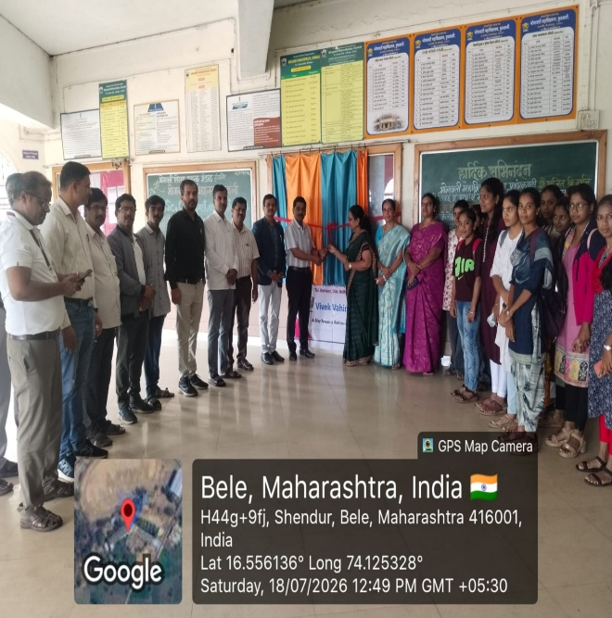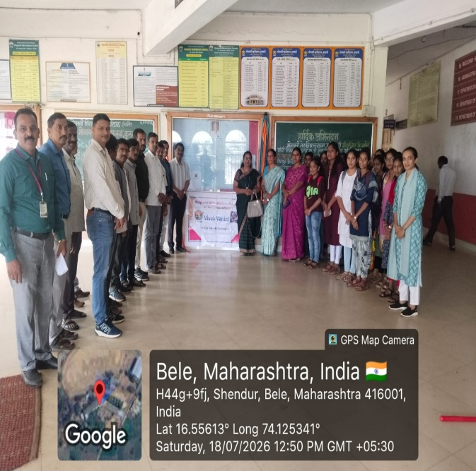
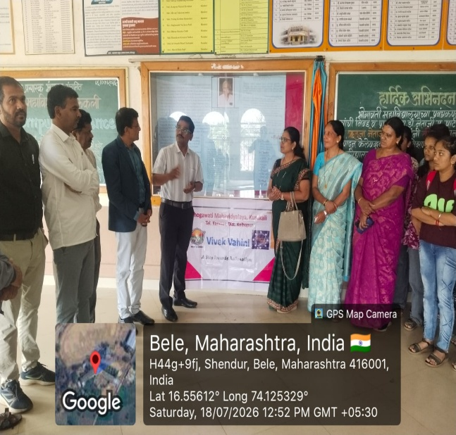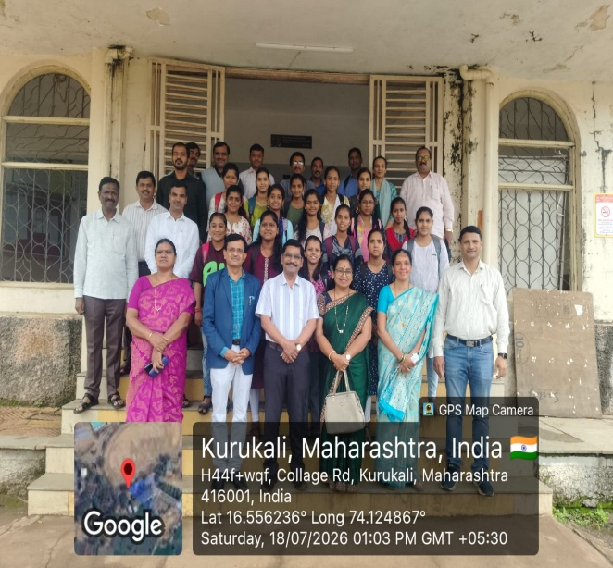
The Chief Guest, Mr. Suryakant Dodmise, addressed the gathering and motivated students to develop an innovative mindset, scientific curiosity, and problem-solving skills. He encouraged them to embrace technology and research while upholding ethical values in their academic and professional lives. Mrs. Dodmise also appreciated the initiative taken by the college to commemorate the legacy of Dr. Jayant Narlikar and to encourage students towards scientific learning.
Principal Dr. Netaji Patil guided the students by emphasizing the significance of scientific thinking, rationality, and continuous learning. He encouraged students to actively participate in the programmes organized by Vivek Vahini throughout the year to enhance their intellectual and personal development.
The programme concluded with a Vote of Thanks proposed by Vice Principal Dr. Nivas Patil, who expressed sincere gratitude to the Chief Guests, Principal, faculty members, students, and everyone who contributed to the successful organization of the event.
A large number of teachers, students and all committee members attended the programme enthusiastically, making the inauguration of Vivek Vahini 2026–27 a memorable and inspiring beginning for the academic year.

Dr. Vibhavari Prakash Malekar
Chairperson, Vivek Vahini

